## Mobile Applications Development 2

## Design Document for Year 3 Semester 6 Mobile Applications Development.

**Student Name:** Aaron Moran

**Student ID:** G00356519

## Project Overview

For our Mobile Applications Development project, we were asked to make a 2D Unity shooter game. We were given a list of Game Requirements which we had to implement to achieve a functioning game.

For my game I decided to mainly focus on the functionality of the game and make sure that all the Components I used and implemented worked accordingly.

The game I have designed is a 2D Top down Shooter which spawns in a wave of enemies from random locations outside the map and they target the Player and follows all the Player sprites movements. The Player must collect all the respected collectables in order to move onwards to the next wave of enemies. Each wave displays more enemies with a quicker spawn rate and ratio. The Player model cannot collide or come in collision with an enemy or the wave will end. You then have the option to either ‘Retry’ or ‘Quit’. The Player can shoot the enemies and when a bullet comes within collision of an enemy object the enemy is destroyed and so is the bullet. As the Player progresses throughout the game the collectables will begin to move making it more difficult for the Player to focus on the moving items and increasing number of surrounding enemies.

## Functionality

1. Menu System
2. Scoring System
3. Multiple Waves
4. Enemy Waves
5. Sound System

# Menu System

I’ve created a very basic Menu UI system where the user has the choices of a ‘PLAY/CONTROLS/TUTORIAL’ buttons. Each button is self-explanatory.

**Play** – Starts the Game.

**Controls** – Displays the list of controls to play the game.

**Tutorial** – Wave to explain the game to the user.



# Scoring System

For the scoring system in my game the Player must collect the rotating items and the score counter will increase. Once all the collectables have been obtained the wave will end and you can proceed to the next wave.

Each wave has its own individual scoring system. The player must reach the required score to pass the wave and once the score is hit the you can proceed.

## Key Binding’s

**WSAD**

The player movement I have chosen for the game is the traditional ‘WSAD’ for PC users. I believe this is a lot more practical than the arrow keys as there is more space for use of a Mouse or other key binds.

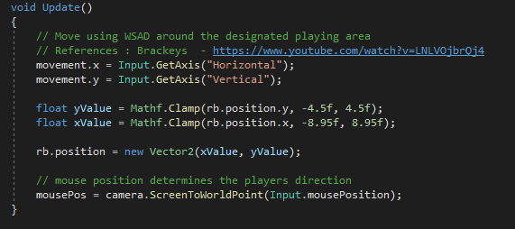

**Mouse1**

For the Player shooting mechanic I also used the traditional ‘Mouse1’ to shoot the bullets from the Player. I have also added the option to use ‘Spacebar’ for anyone who wishes to use it instead as its close to the ‘WSAD’ keys.

**ESC**

Using the ‘ESC’ key will trigger the Pause Menu. Within the pause menu are 3 options:

1. RESUME – Resume the gameplay.
2. RESTART – Restart the wave.
3. QUIT – Quit to Main Menu screen.

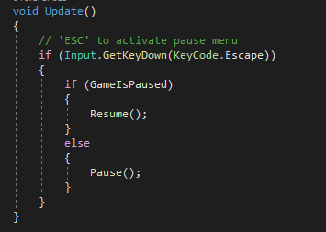

**AIM**

To aim your player in the direct of the enemies and shoot bullets you must use a Mouse in order to determine its direction. The main camera is locked to the player movement and look direction.

## Waves

I have designed each wave so that it increasingly gets more difficult. There is no wave within the game that is not possible to complete. Although the speed of enemies and number of enemies does increase it is still possible to complete the game.

Each wave has a designated number of enemy spawns per second. The further you go within the waves the faster these spawn times get and the larger in quantity the enemies gather.

There is no limit on how many enemies can be alive during each wave, but the number will not go beyond 10 as the enemies would have destroyed the Player Game Object before the game decides to glitch.

## Splash Screen

My Splash Screen displays my name and Student ID number. This will fade in for only 3 seconds before the Main Menu is loaded up.

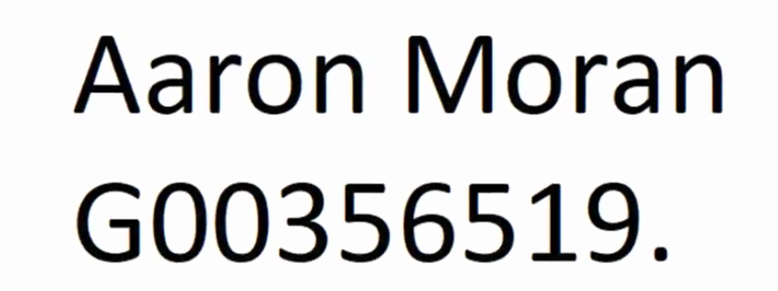

## Sound System

For my project I have used some basic sound systems.

* I have music constantly playing through in the background as a game suspense. This music will loop once the clip finishes playing.
* Whenever a wave starts an Audio source clip plays to alert this action.
* Whenever a Player shoots a bullet an Audio source clip plays of a gun shooting sound.
* And I have an Audio source clip that plays when you die to an enemy.

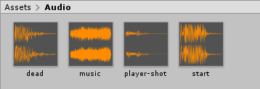

## Sprites

The sprites I have designed for the game were all drawn using Piskel and Photoshop. The player Sprite is inspired by the Half-Life logo, so therefore I used the circular structure with the Lambda symbol inside. The enemy sprites are the symbol of ‘Pi’ and the collectables are of a ‘Nuke’ symbol.

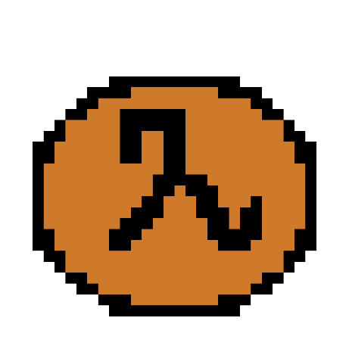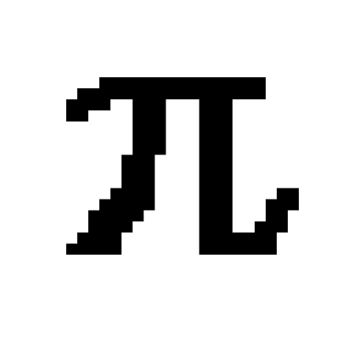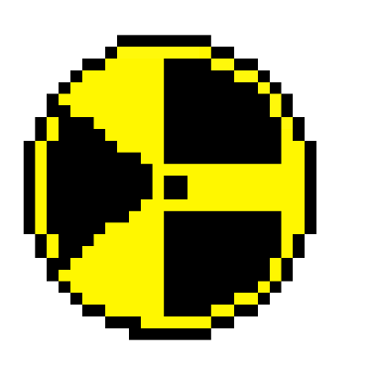

## References

Below is a list of references I used to complete the project:

* Damien Costello – GMIT Lecture/Year Head.
* Brackeys (Top Down Movement and Shooting) - <https://www.youtube.com/watch?v=LNLVOjbrQj4>
* Alexander Zotov (Score Counter) -https://www.youtube.com/watch?v=QbqnDbexrCw
* Stack Overflow - https://stackoverflow.com/
* Reddit - <https://www.reddit.com/r/Unity2D>
* Photoshop CS6 -https://www.adobe.com/products/photoshop.html
* Piskel - <https://www.piskelapp.com/>